Answers to problems 6, 7, 2, 3 (in descending order)

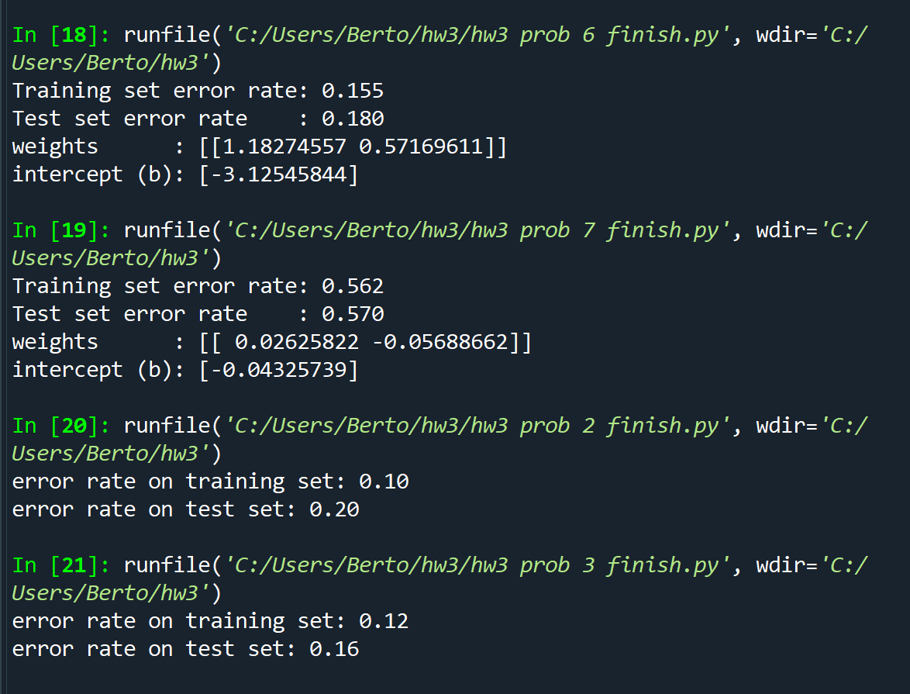

6.) the results look reasonable due to both the training set error rate (15.5%) and the testing set error rate (18%) being relatively low.

7.) the results do not look reasonable due to both the training set error rate (56.2%) and the testing set error rate (57%) being moderately high.

2.) looking at the training set error rate (10%) for the results of the neural network, it seems to have gotten lower than when compared to the logistic regression while the testing set error rate (20%) seems to be slightly higher than the logistic regression.

3.) here both the training set error rate (12%) and the testing set error rate (16%) are lower than the logistic regression version of the problem.

Problem 6 - code

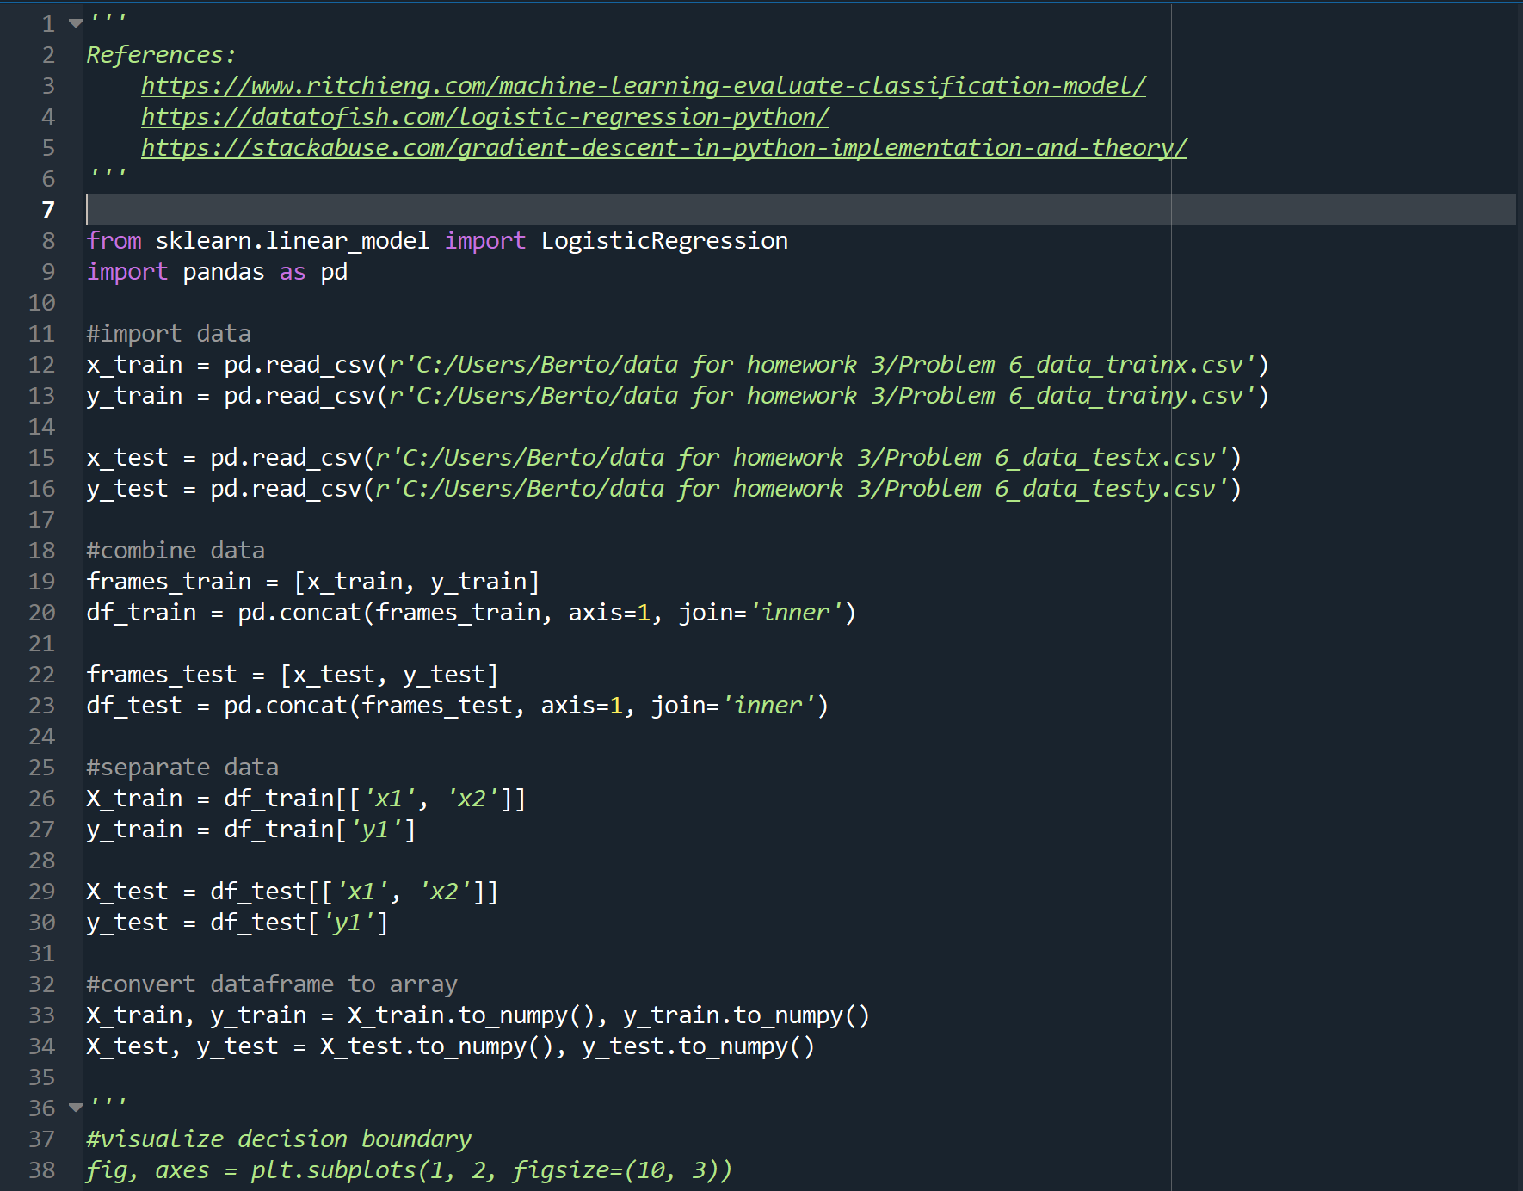

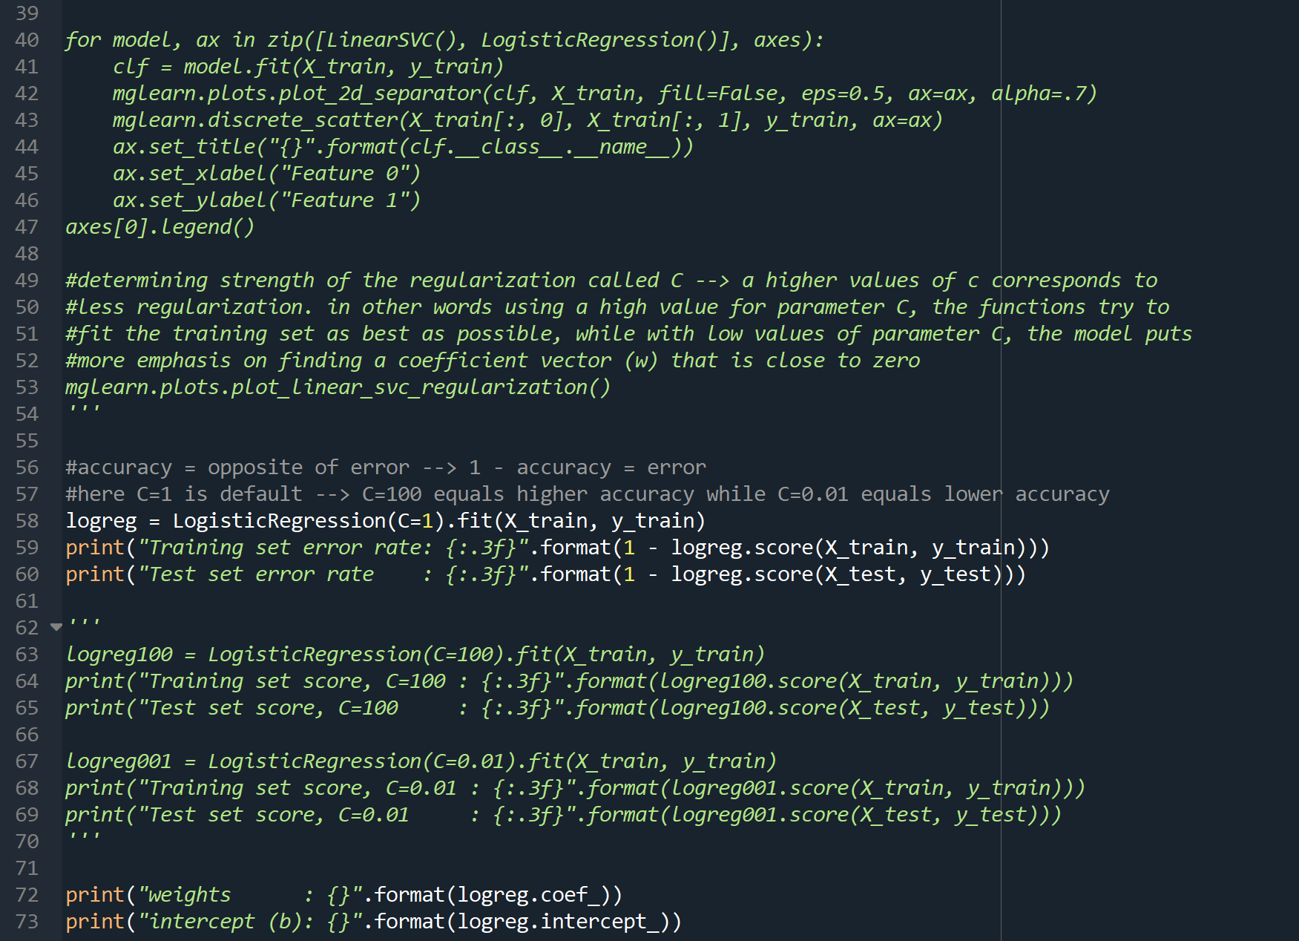problem 6 – code (continued)

Problem 7 – code

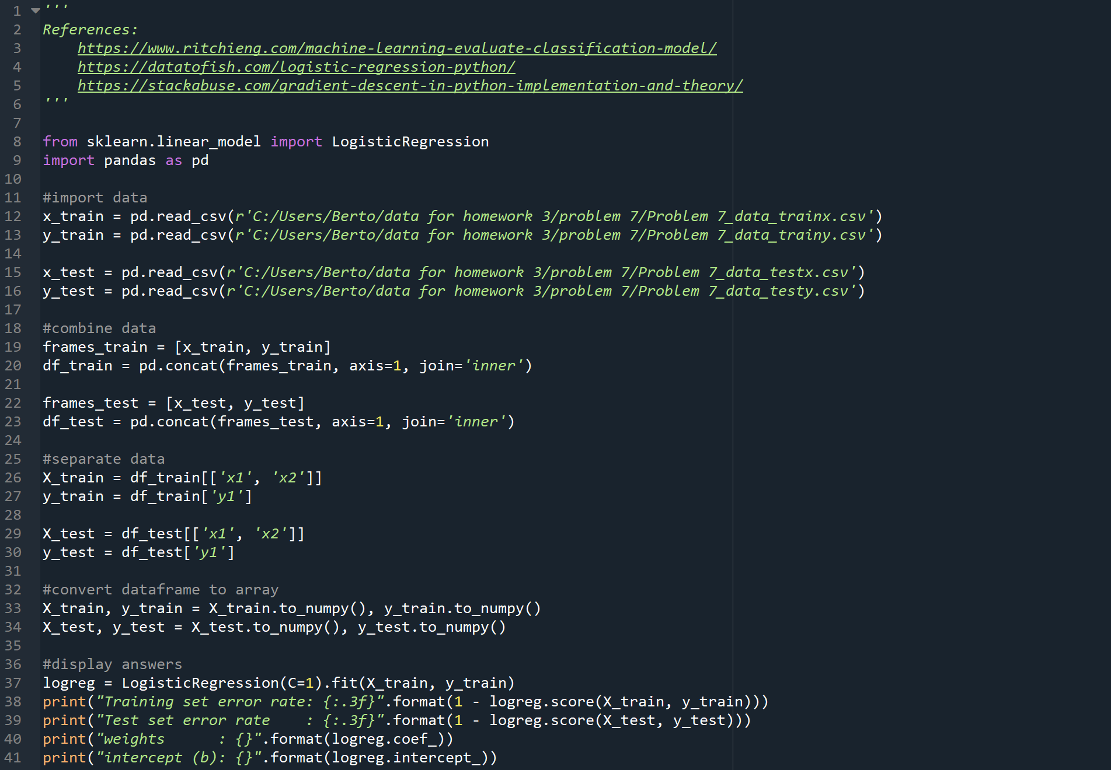

Problem 1

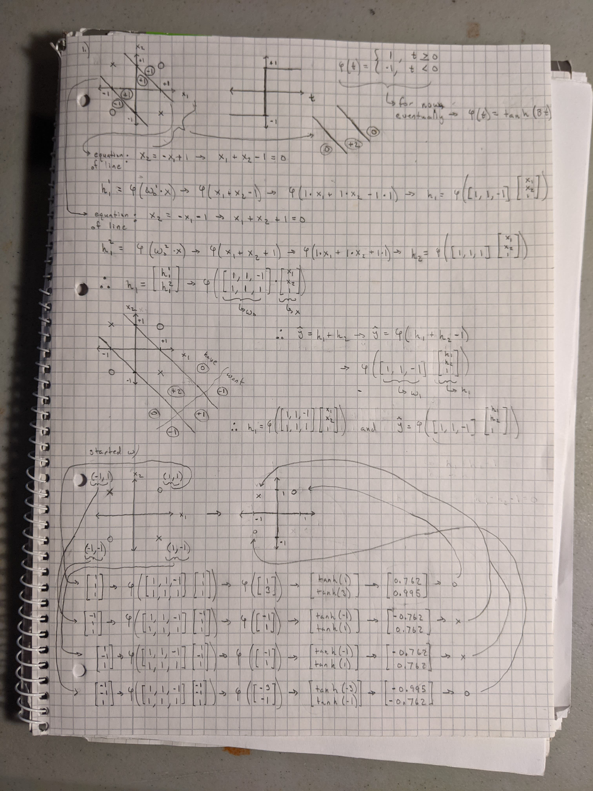

Problem 2 – code

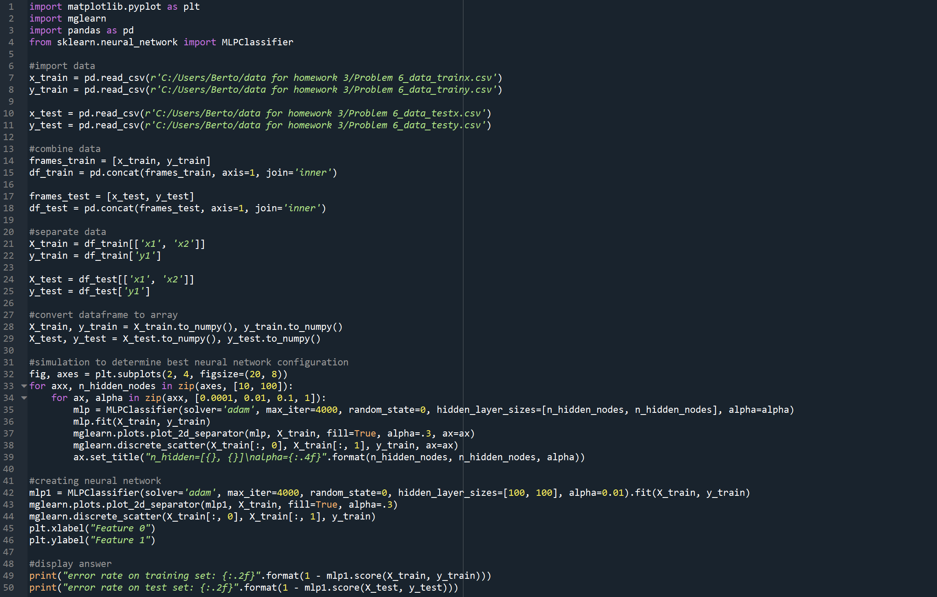

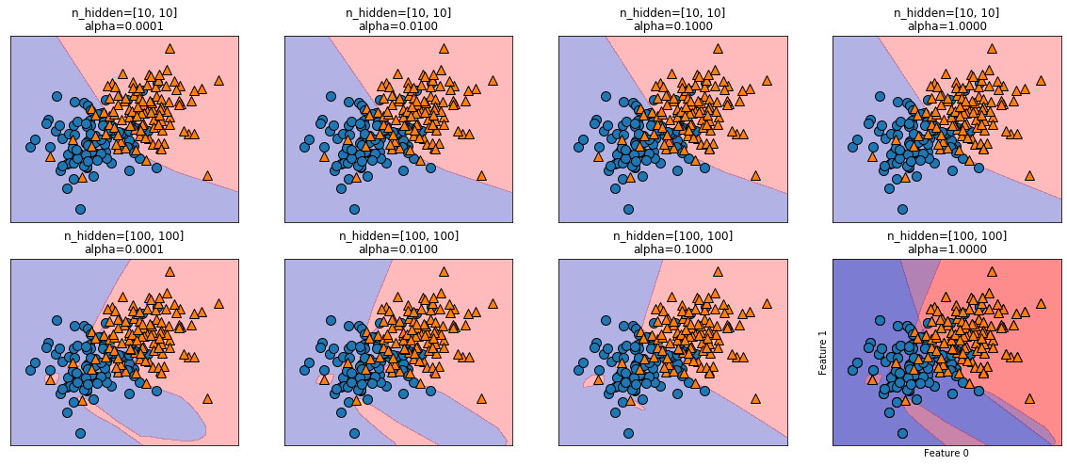

Simulation results to see what the best parameters were by changing the number of hidden layers and the alpha value.

Problem 3 – code

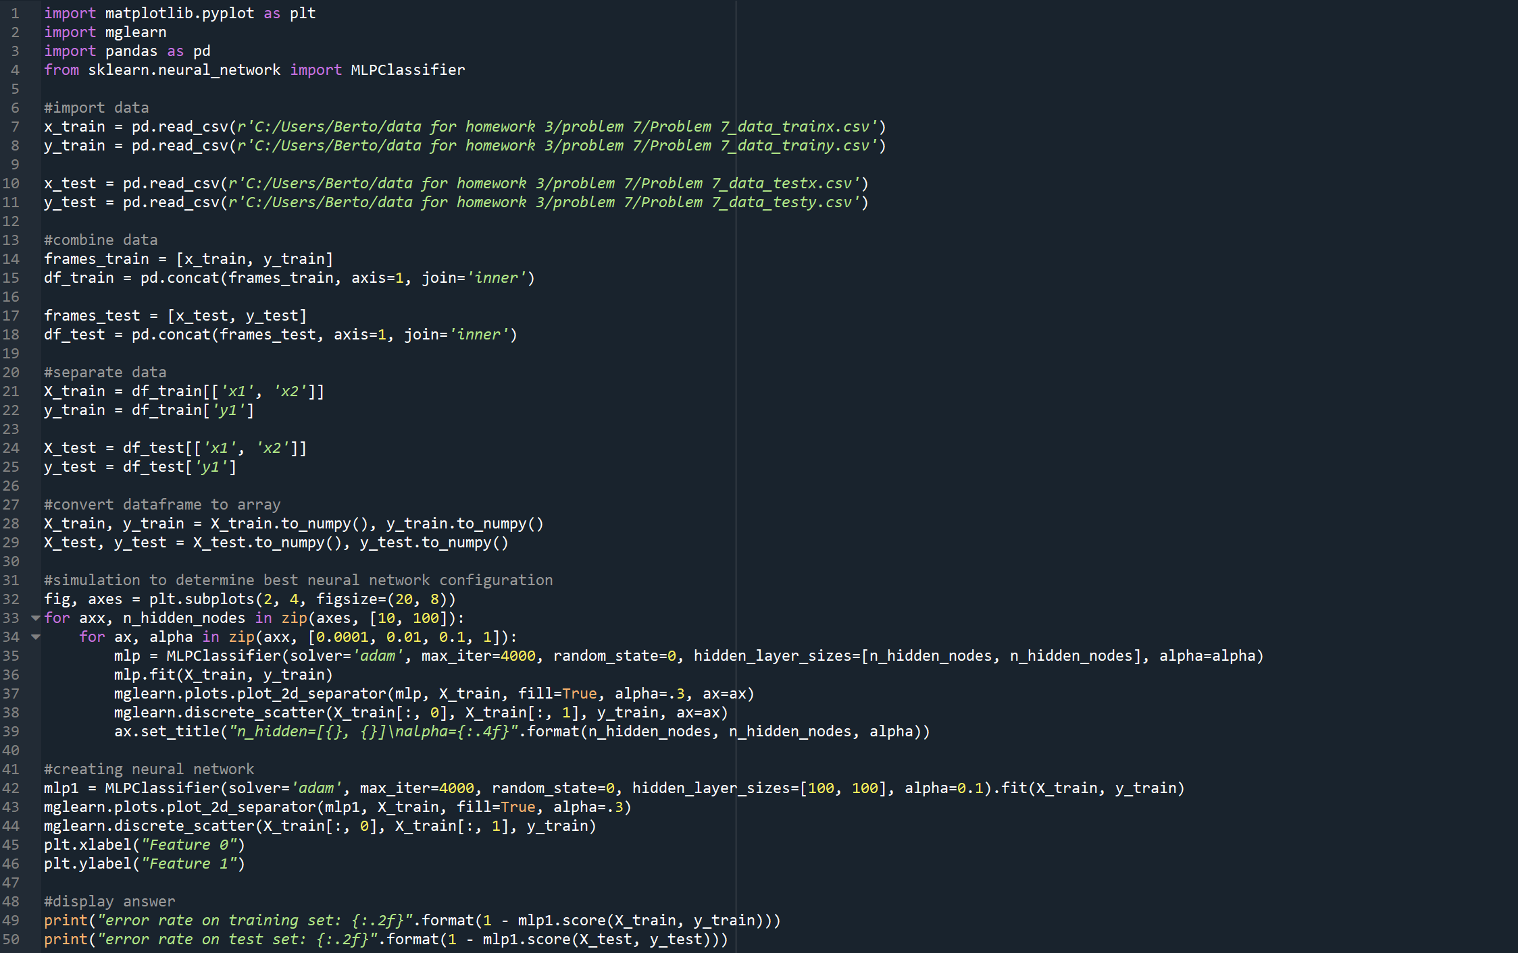

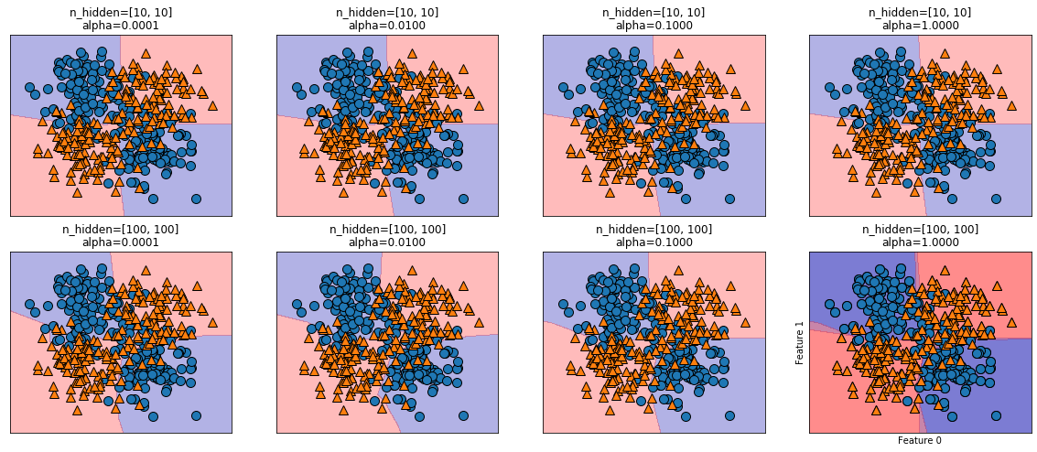

Simulation results to see what the best parameters were by changing the number of hidden layers and the alpha value.

Problem 4 – code

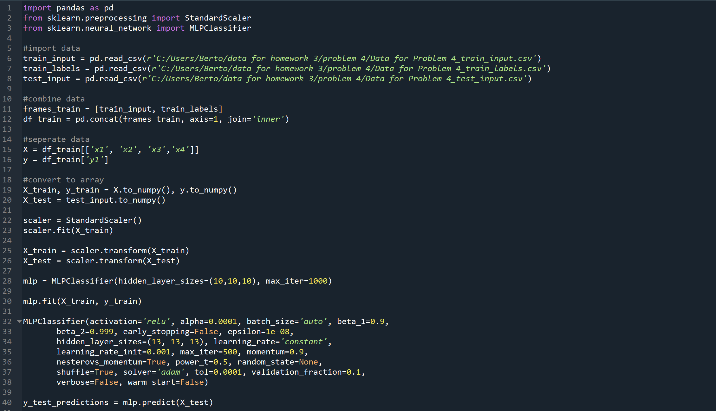

Reference for what all of the parameters of the MLPClassifier mean/ do:

[sklearn.neural_network.MLPClassifier — scikit-learn 0.24.1 documentation](https://scikit-learn.org/stable/modules/generated/sklearn.neural_network.MLPClassifier.html)

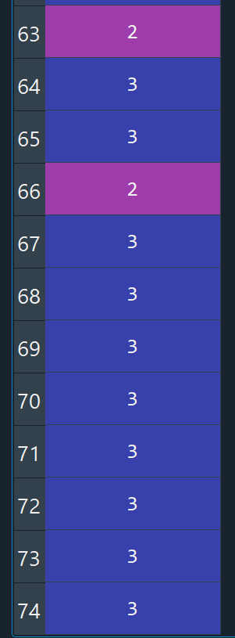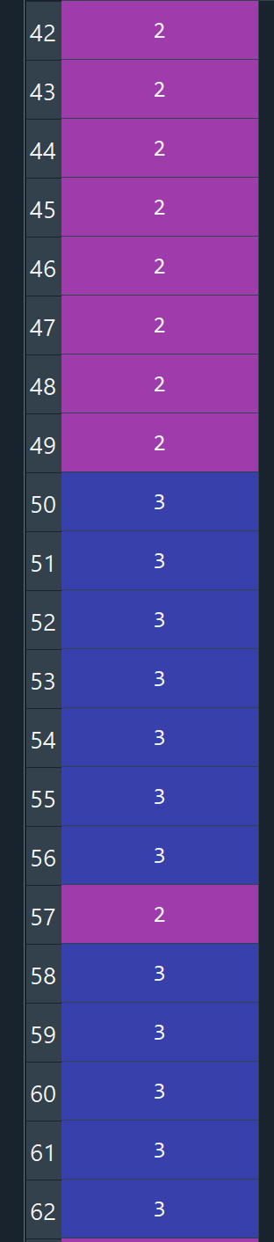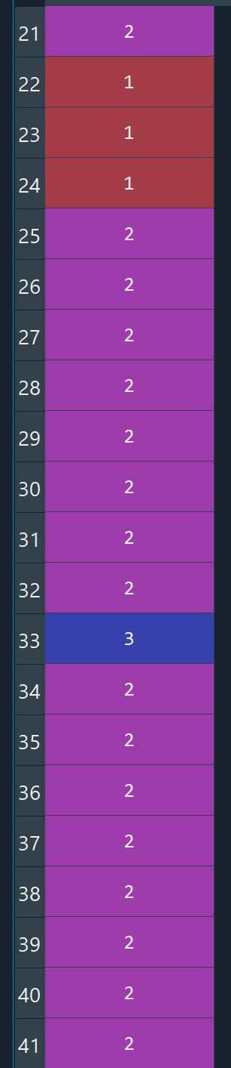Problem 4 – output